t

Public Works will be conducting road repairs on Foothill Boulevard beginning July 10. One-way traffic controls will be in place between 8:00 a.m. and 5:00 p.m. and the road will be closed to pedestrian and bicycle traffic. Please plan alternate route.

The Foothill Boulevard Road Repairs project will affect vehicle and pedestrian traffic from 8:00 a.m. to 5:00 p.m. Monday-Friday, 7/10-7/20/2015

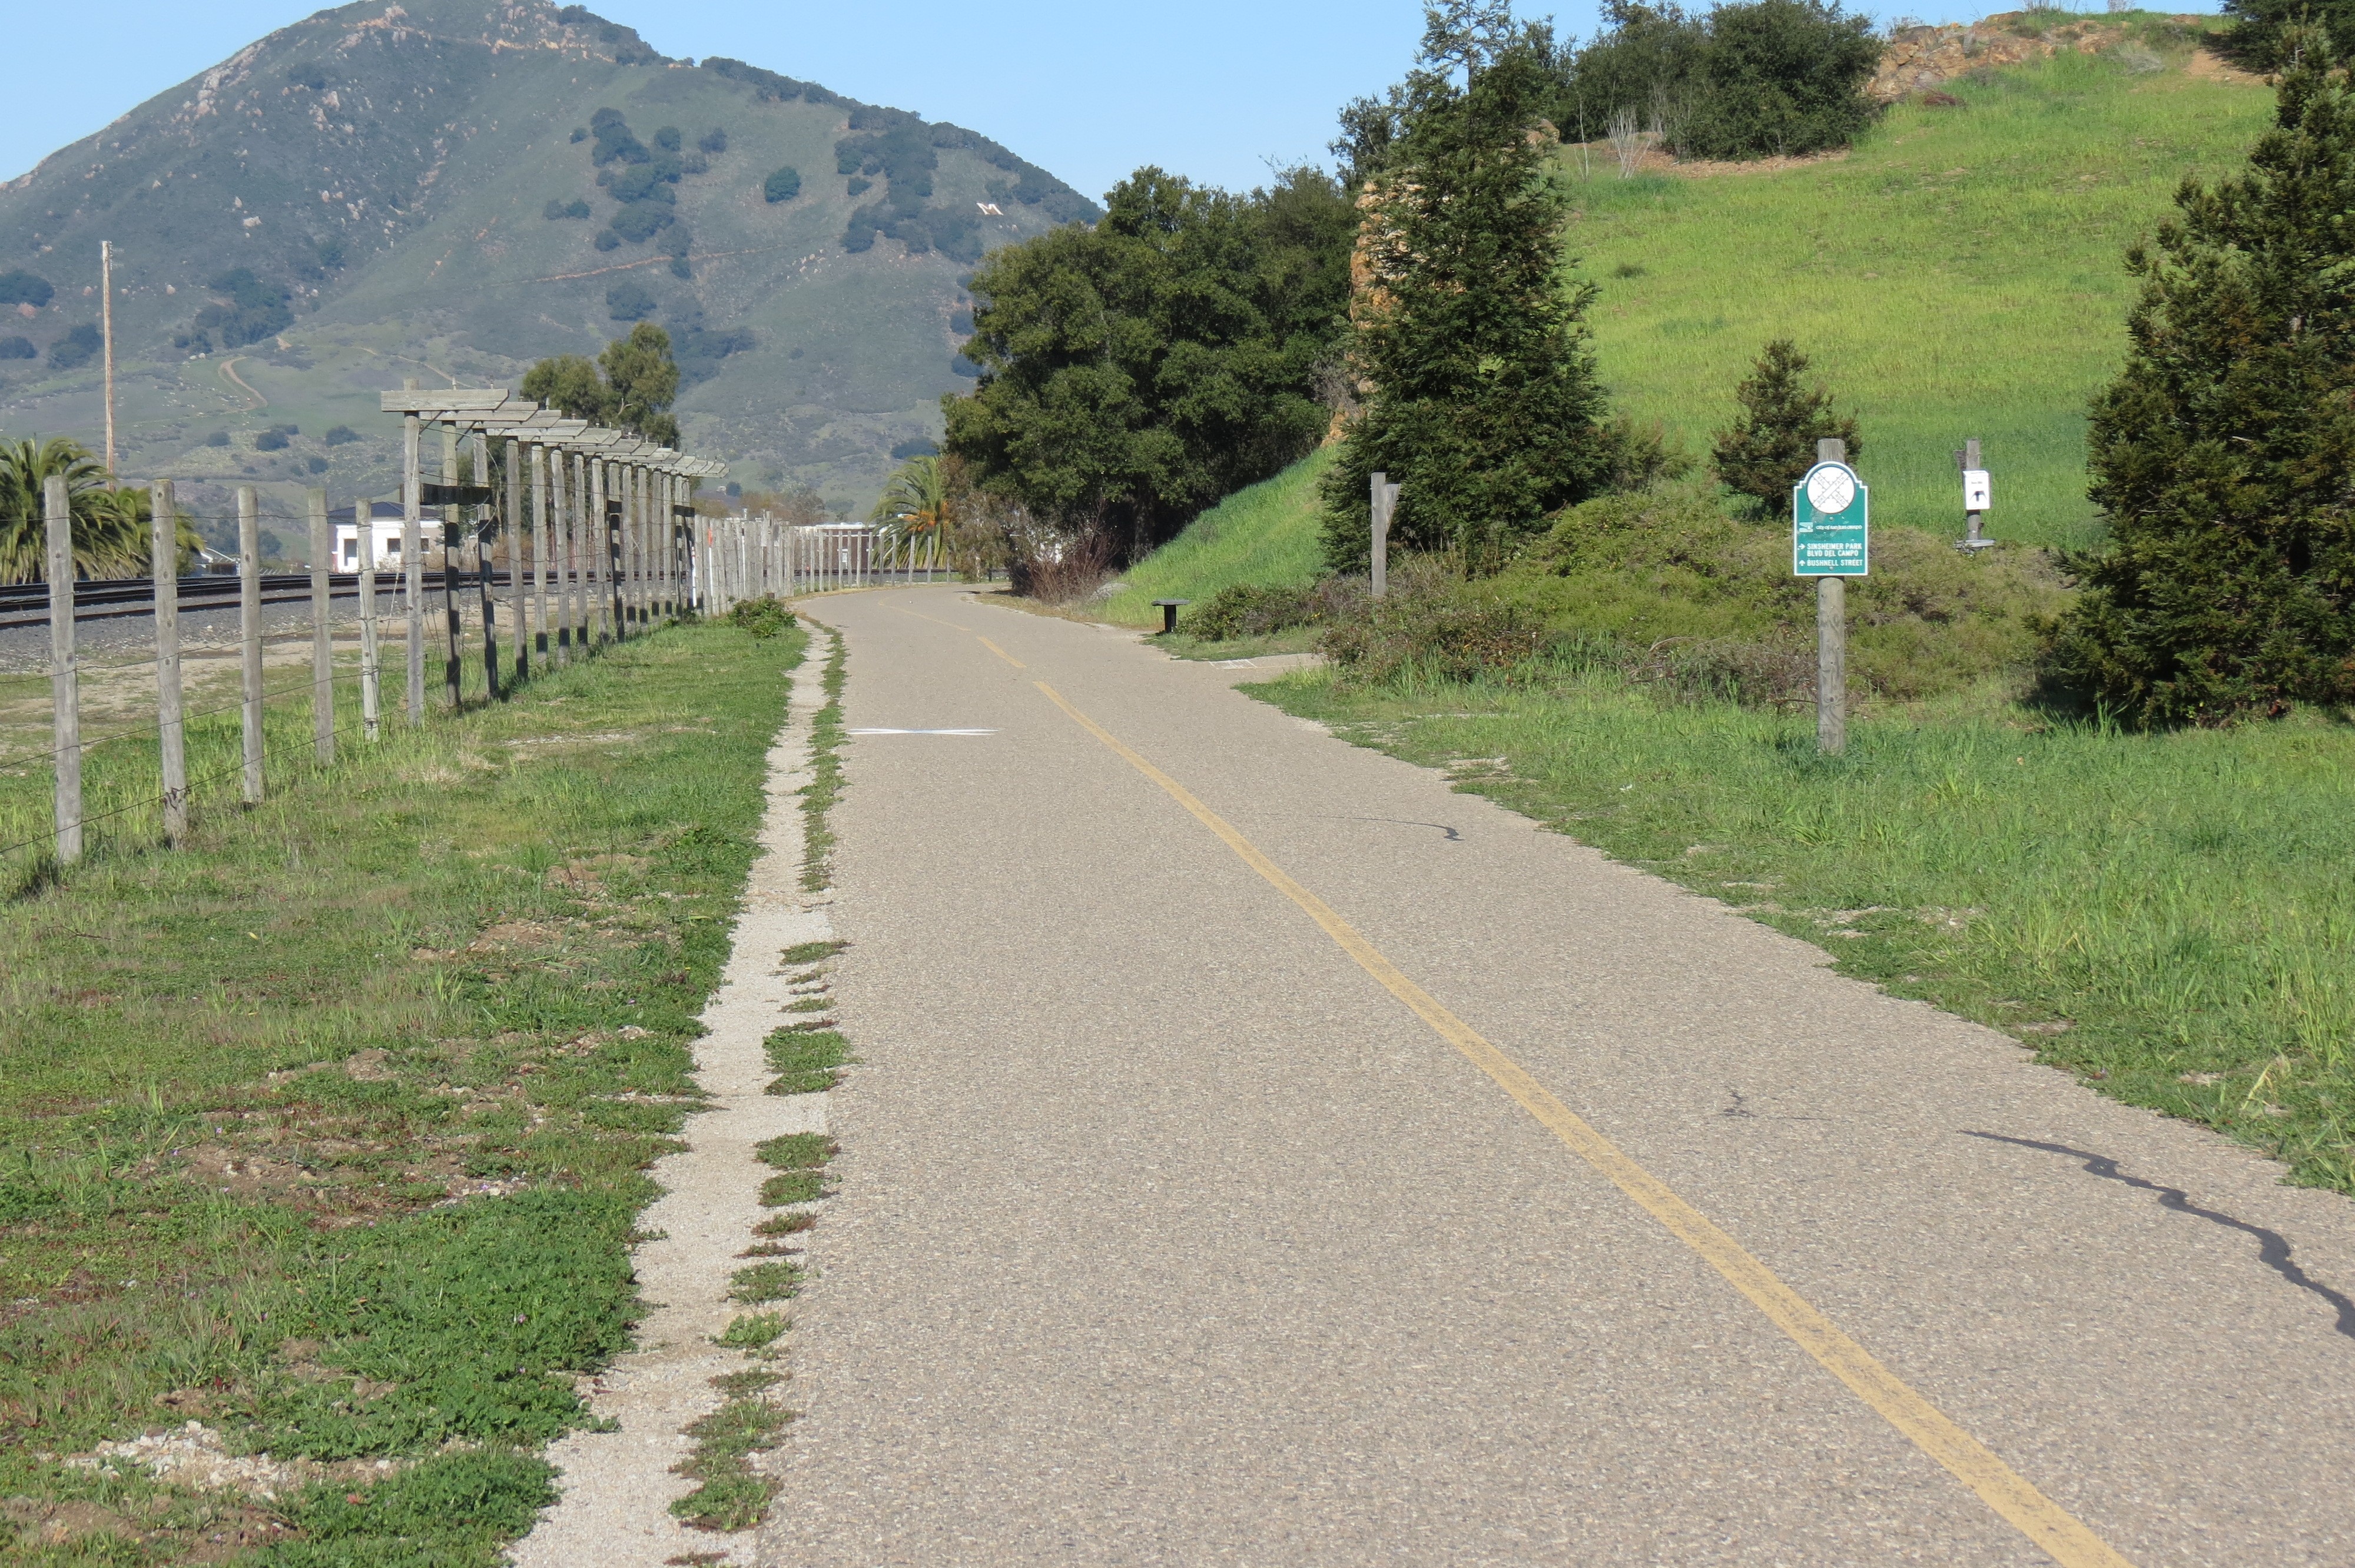

ATTENTION FOOTHILL COMMUTERS

Foothill Boulevard Road Repairs

For more information, visit the Public Works page on the city website, [http://www.slocity.org/government/department-directory/public-works](http://slocity.org/government/department-directory/public-works).

You can also email [info@slocity.org](mailto:info@slocity.org) or call (805) 888-8888.